Application Endpoint........................................................1-1

Log-in................................................................................1-1

Features of the Application...............................................1-4
Top-left corner............................................................3-3
Top-right corner.........................................................3-3
Middle........................................................................3-4

Settings..............................................................................5-6
Add New Topics..................................................................5-6
Delete Existing Topics........................................................6-6

Application endpoint:

The application can be accessed via the URL below:

https://atosrail.azurewebsites.net/

Log-in:

After accessing the website the user needs to enter their credentials provided by the system admin/manager. There is no sign up option as this is a private application and thus the user must already have the log-in details beforehand.
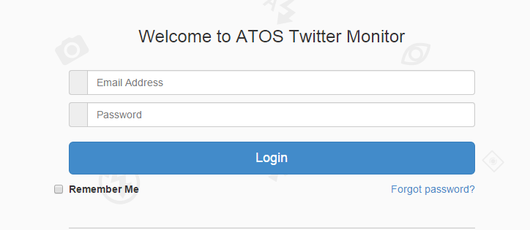
Features of the application:

All the functions of the application is is available on the top of the screen.

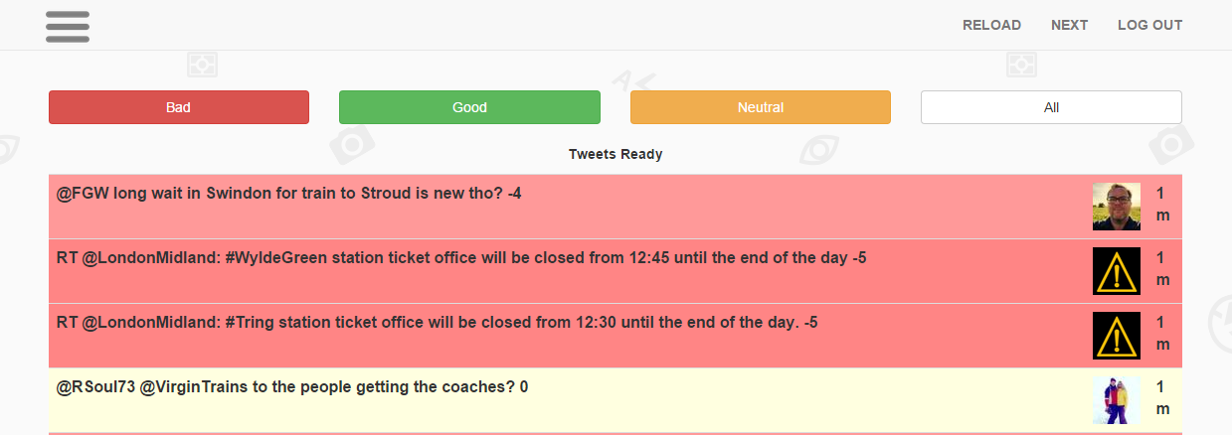
Top-left corner:
On the top left hand corner we have the settings button. This will re-direct the user to the settings page where they can change the tweet parameters as they wish.

Top-right corner:
On the top right corner there are three options: “RELOAD”, “NEXT”, “LOG OUT”.

The reload button refreshes the page and fetches a new batch of the latest 100 tweets. This is to be used when the user has finished inspecting the current set of tweets and wants to look at the new ones.

The next button refreshes the page and displays a set of 100 tweets. These 100 tweets are the one that were tweeted immediately before the last tweet in the current page. So if the last tweet on this page was 40 minutes ago, clicking the refresh button would show 100 more tweets which were tweeted more than 40 minutes ago.
Last tweets on current page:
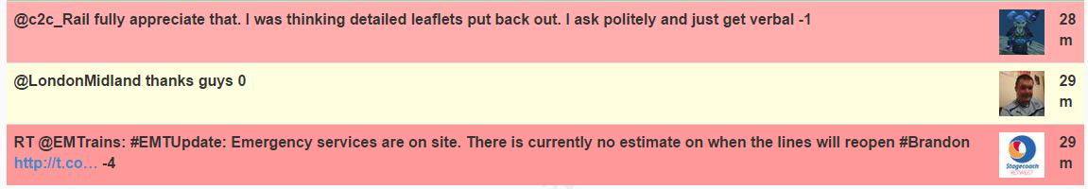
First tweets on the page loaded after clicking “NEXT”:
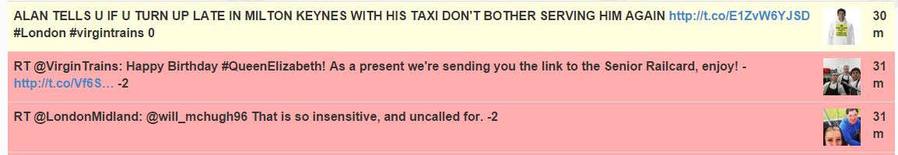
The “LOG OUT” will re-direct the user to the log-in page and the user will have to re-enter their details to gain access to the application again.

Middle:
In the middle we have 4 buttons: “BAD”, “GOOD”, “NEUTRAL”, “ALL”

Bad:
When clicked it will re-direct the user to a page where the only available tweets are the ones with a negative sentiment. These tweets are gathered from the set of 100 tweets initially fetched.
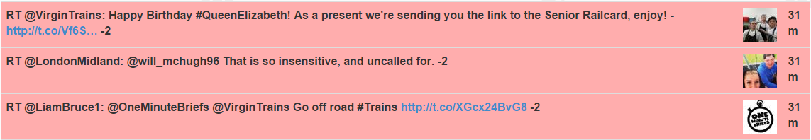
Good:
When clicked it will re-direct the user to a page where the only available tweets are the ones with a positive sentiment. These tweets are gathered from the set of 100 tweets initially fetched.

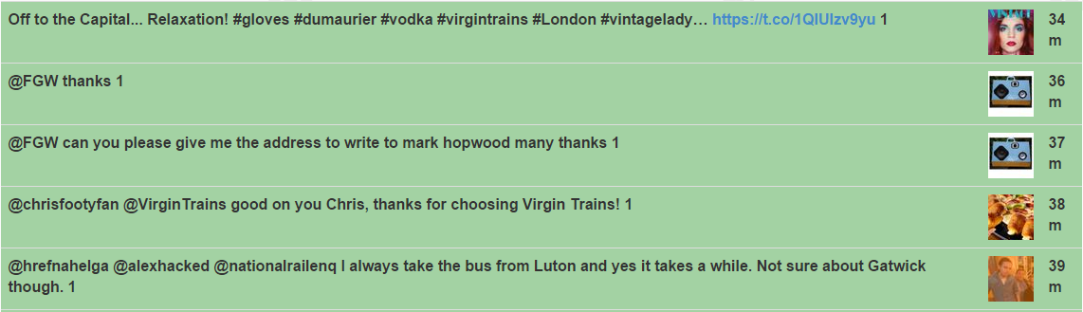
Neutral:
When clicked it will re-direct the user to a page where the only available tweets are the ones with a neutral sentiment, i.e. neither positive or negative. These tweets are gathered from the set of 100 tweets initially fetched.

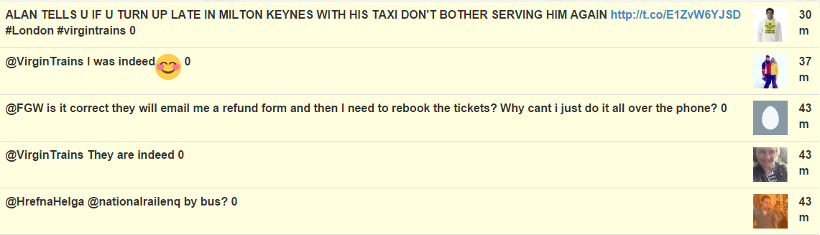
All:
When clicked it will re-direct the user to a page where the initials 100 tweets are visible in the order that they were fetched. The purpose of this button is to be able to let the user come back to the initial 100 tweets from the “BAD”, “GOOD” or “NEUTRAL” page. If the user clicks on this button while being on the home page (Home page being defined as the page seen immediately after log-in or reload or next) it will have no effect.

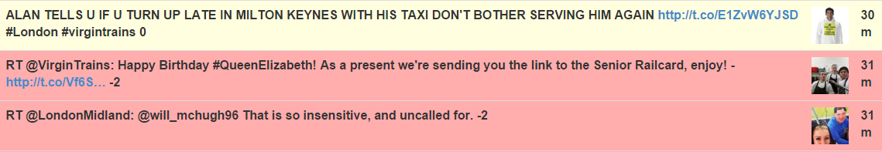
Settings:

The settings page can be accessed via clicking the top-right corner button.

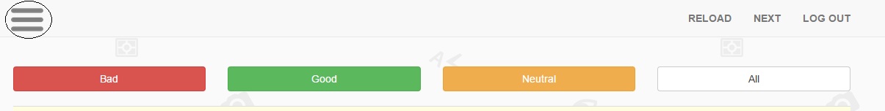
After clicking on the button the user will be re-directed to the following page:

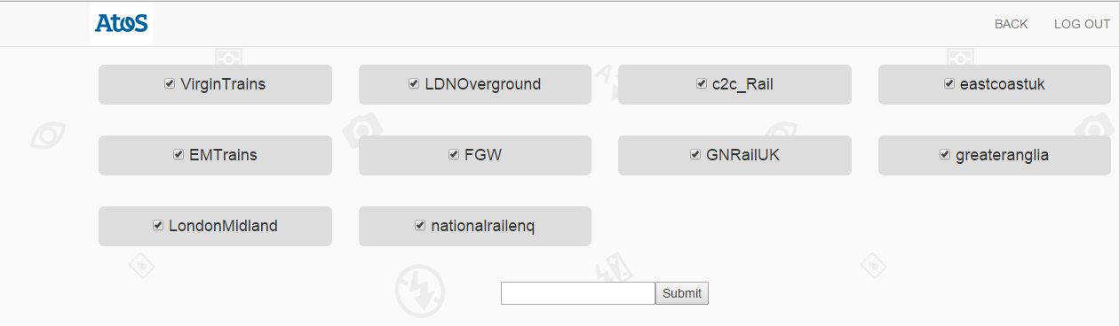
The “BACK” button on the top right corner will take the user back to the home-page and the “LOG OUT” button will log the user out of the system and take them to the login page.

Add new topics:

To add a new topic the user must write it in the text box. It is possible to add multiple topics at once and the user must space delimit these name. For example, if I want to add “alphaTesting” and “betaTesting” to the set of tweets I want to follow I will write the folloeing in the text box and press submit: “alphaTesting betaTesting”.

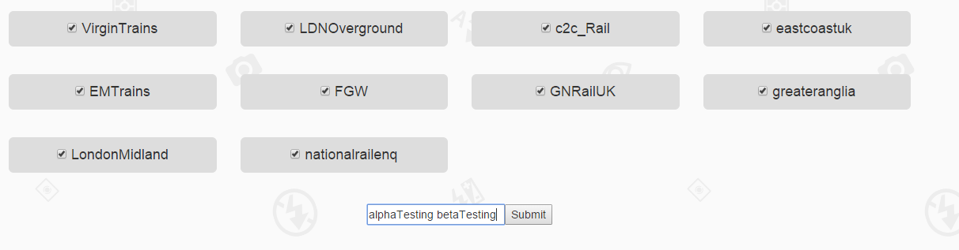

Upon clicking submit the two new topics will be immediately added to the set of tweets.

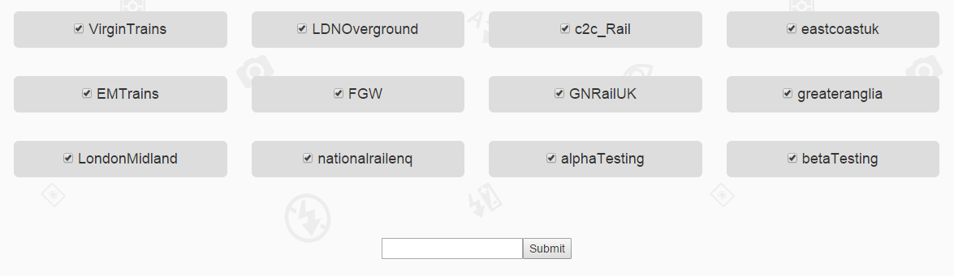
It is important to note that no # or @ should be put in the text box. This is because the application will take each individual word in the setting page and automatically look for #word @word.

Delete existing topics:

To delete any entry from the settings page un-tick the arrow inside the grey box that contains both the word and the arrow.

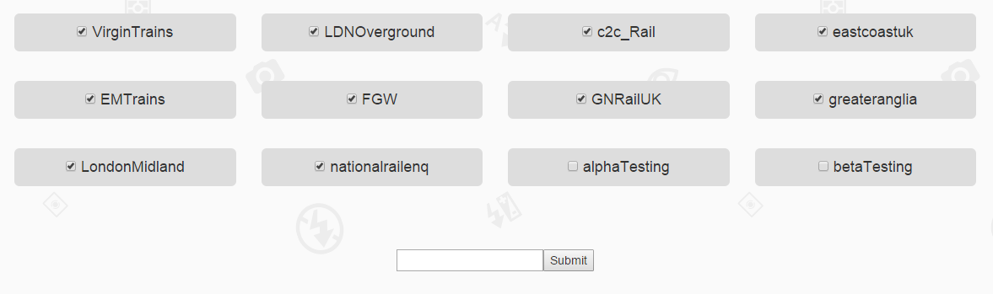
Now click on the either one of the un-ticked boxes and the page will refresh and delete those entries.

Both adding and deleting multiple tweets can be done in the same time. In this case un-tick all the entries that the user wants deleted and write the new topics in the text-box and click submit. This will delete all the chosen entries and add the new ones.

